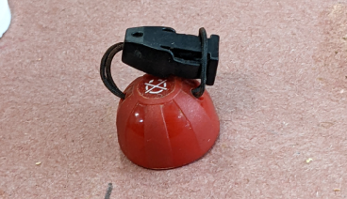
Remove the magnet from the bike and remove the string from the magnet and put it down on a flat, sturdy surface like a work bench or a hard floor

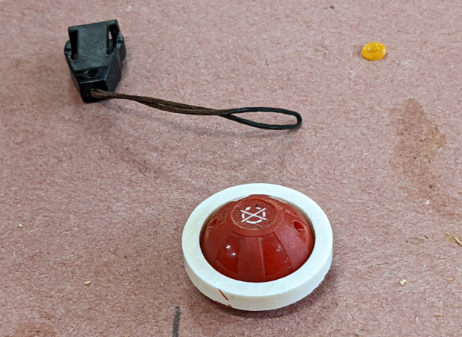

Place the ring over top of the magnet, it won’t quite go to the bottom

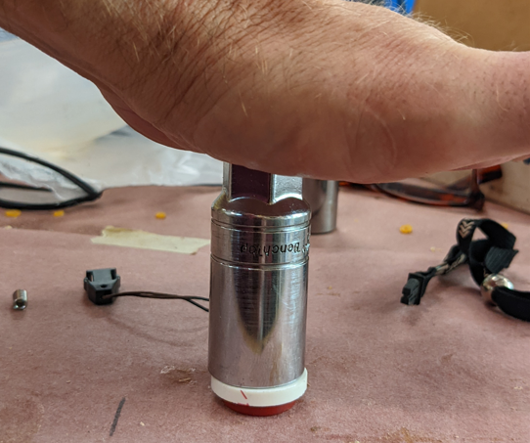
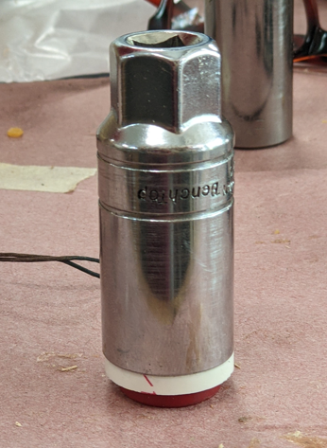
Place a standard 13/16” spark plug socket over the ring and push down with your body weight

You will push the ring down to the bench/floor surface; the bottom of the ring will be even with the bottom of the magnet and will fit snugly in place
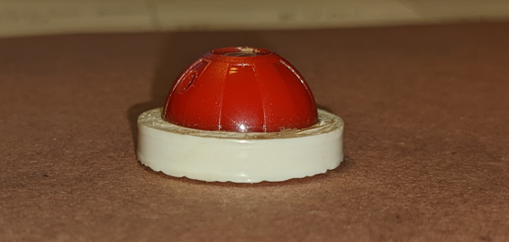

Use the wire to thread the string back through the hole in the magnet and re-assemble your tether

